**Name: Nishit Shaileshbhai Rathod**

**Student Number: N01586439**

**Course: Machine Learning in Cloud Computing - AIGC-5003**

**Assignment 6**

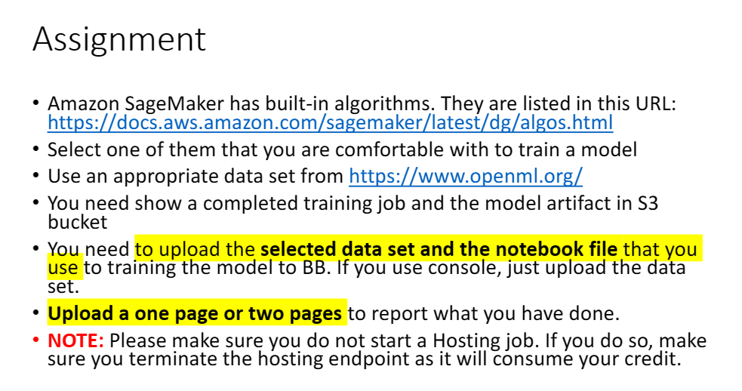

**About the dataset:**

* **The transplant dataset is taken from** [OpenML](https://www.openml.org/search?type=data&sort=runs&status=active&qualities.NumberOfInstances=lte_1000&qualities.NumberOfFeatures=lte_10&qualities.NumberOfClasses=lte_1&id=544).
* **It is about on patient deaths within 30 days of surgery in 131 U.S. hospitals. For which, please go through “Christiansen and Morris, Bayesian Biostatistics, D. Berry and D. Stangl, editors, 1996, Marcel Dekker, Inc.”**
* **The Data is on 131 heart transplant hospitals in the US. The 3646 transplants took place during a 27 month period from October 1987 through December 1989.**
* **The columns are: obs = hospital #, e = expected # of deaths within 30 days of the transplant surgeries, z = number of deaths within 30 days of surgery, n = # of patients receiving heart transplant within this time period. (Christiansen and Morris, Bayesian Biostatistics, D. Berry and D. Stangl, editors, 1996.)**
* **The patient level data which was used to create this data set was provided by the United Network for Organ Sharing, 1100 Boulders Parkway, Suite 500, P.O. Box 13770, Richmond, VA, 23225.**

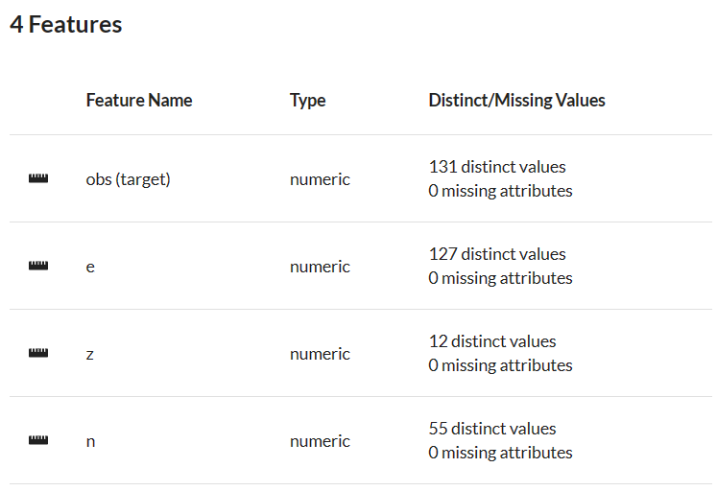

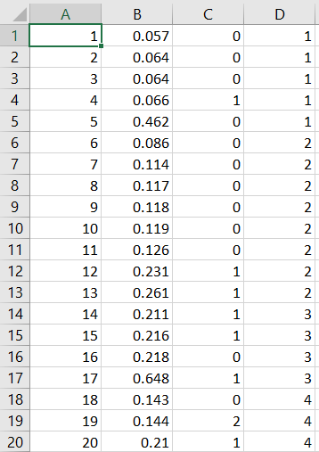

**Step 1: Create a S3 bucket and inside this S3 bucket create a folder named transplant_console.**

**Step 2: Now, add three folders in transplant_console and call it as “training_console”, “validation_console” and “output”. After which, add two .csv files called “Transplant_Training_Console.csv” and “Transplant_Validation_Console.csv” to the respective training and validation folders by ensuring 70:30 train test split ratio.**

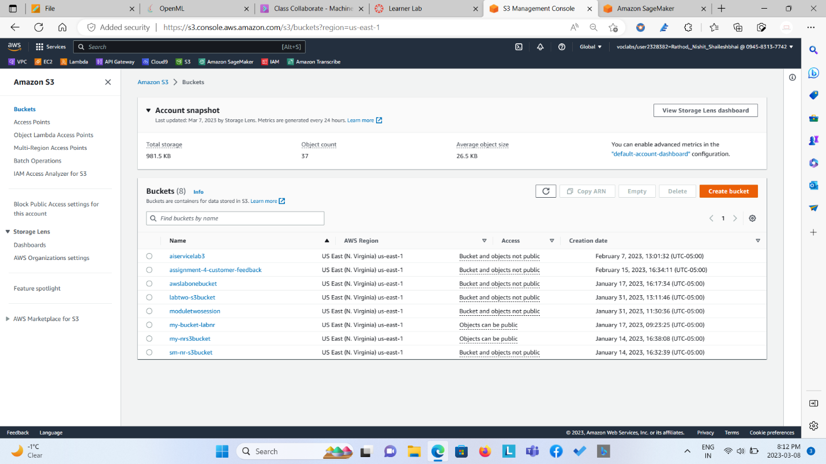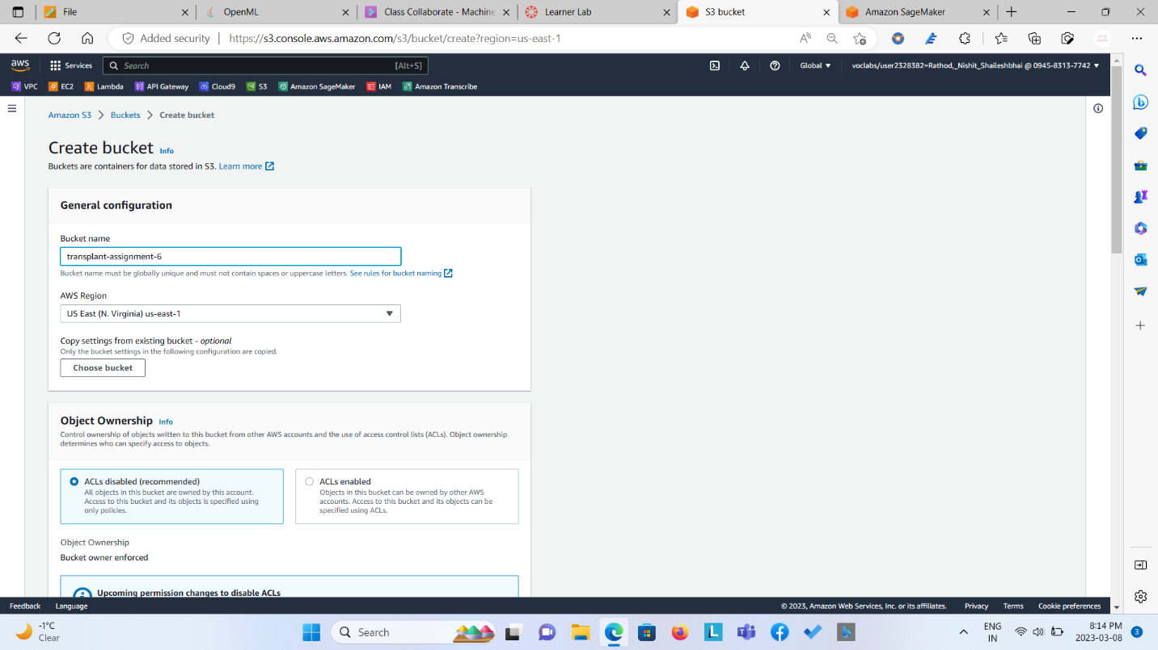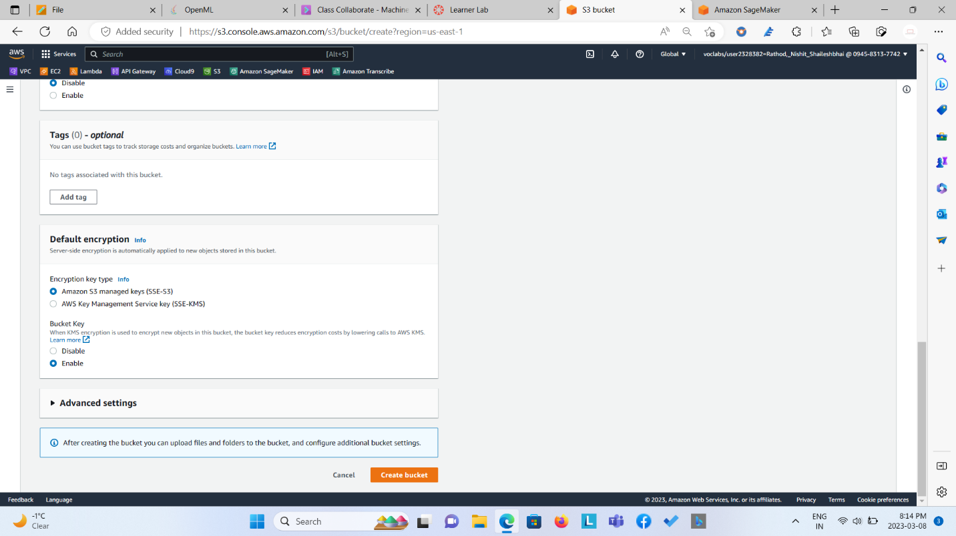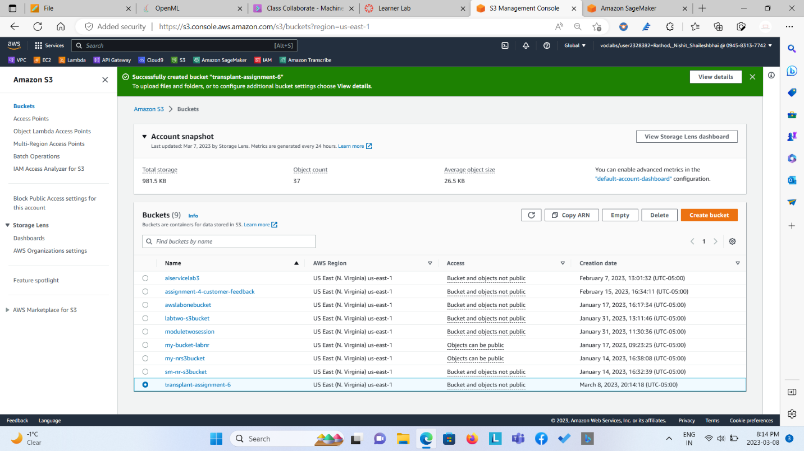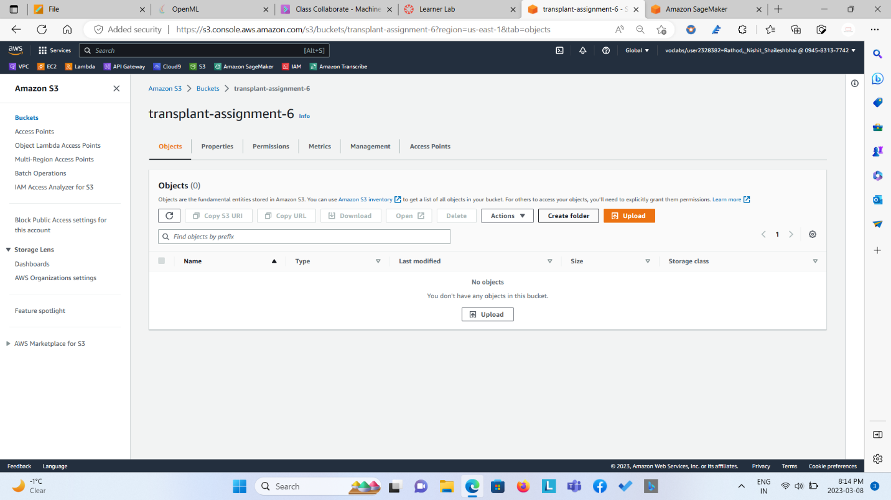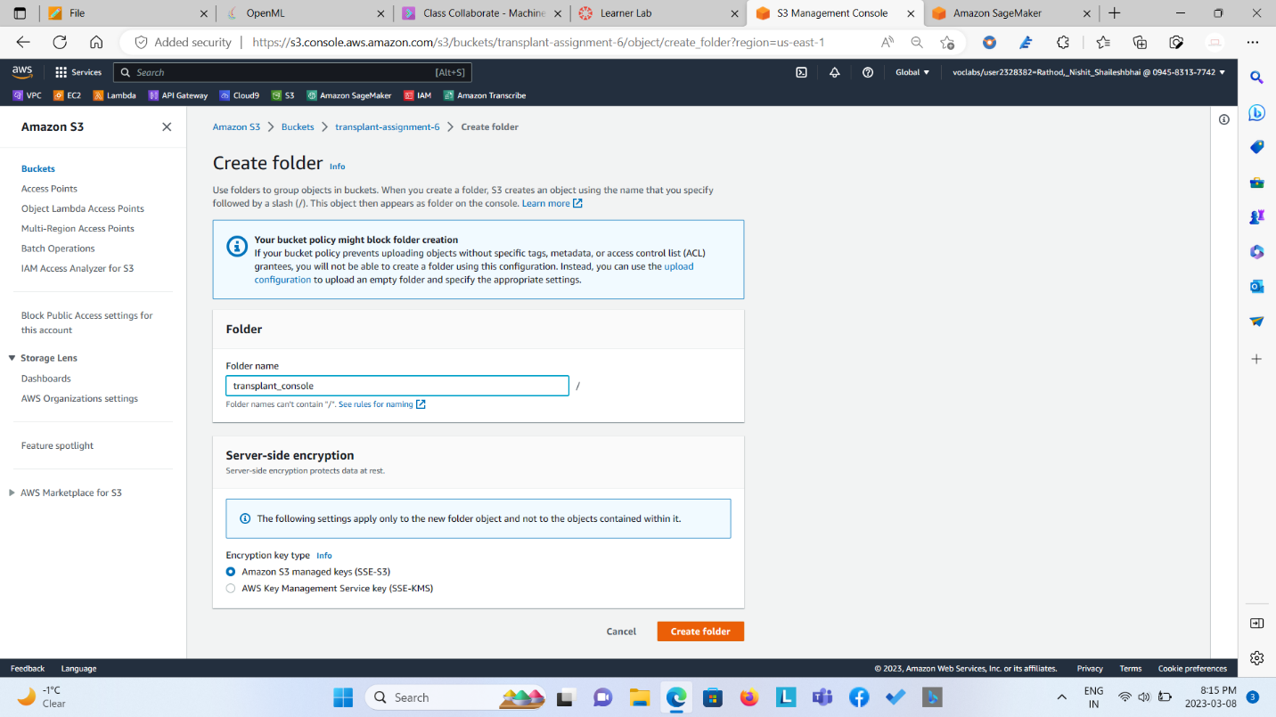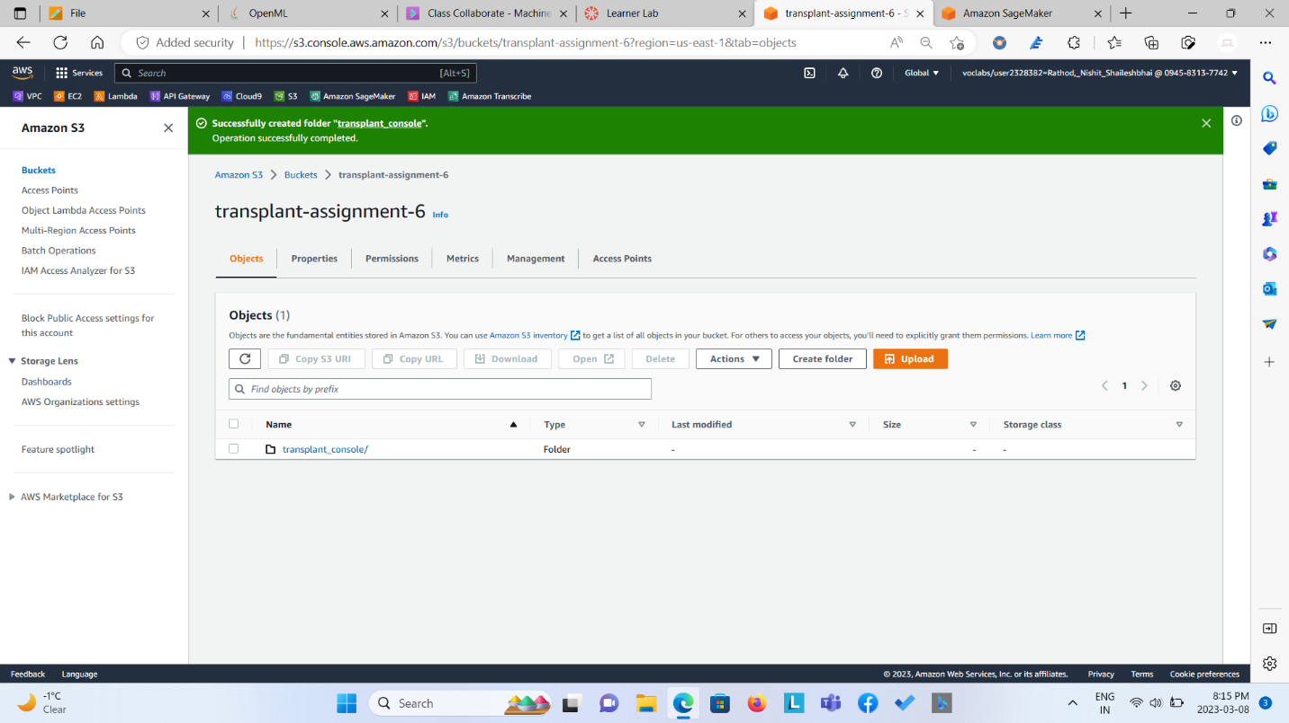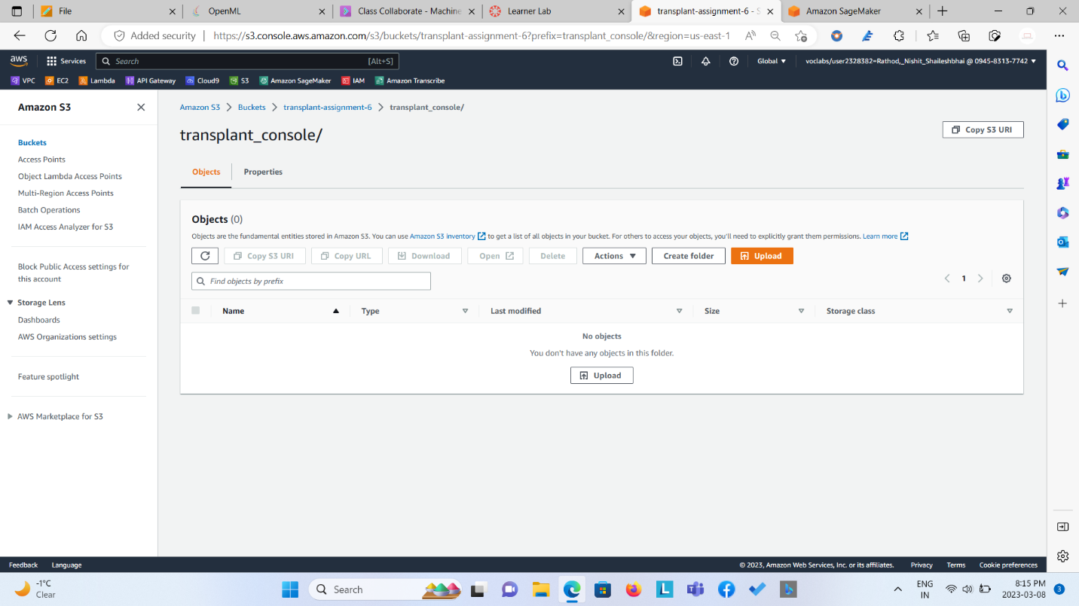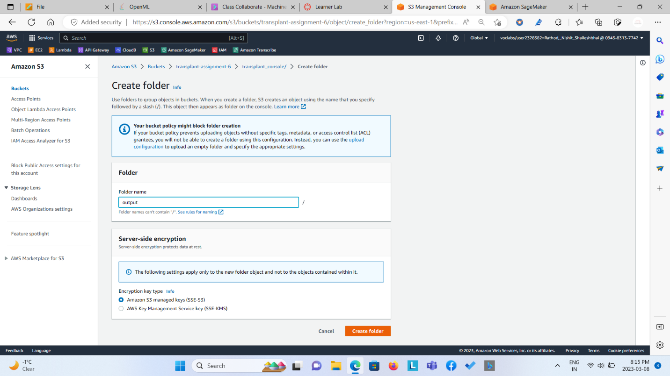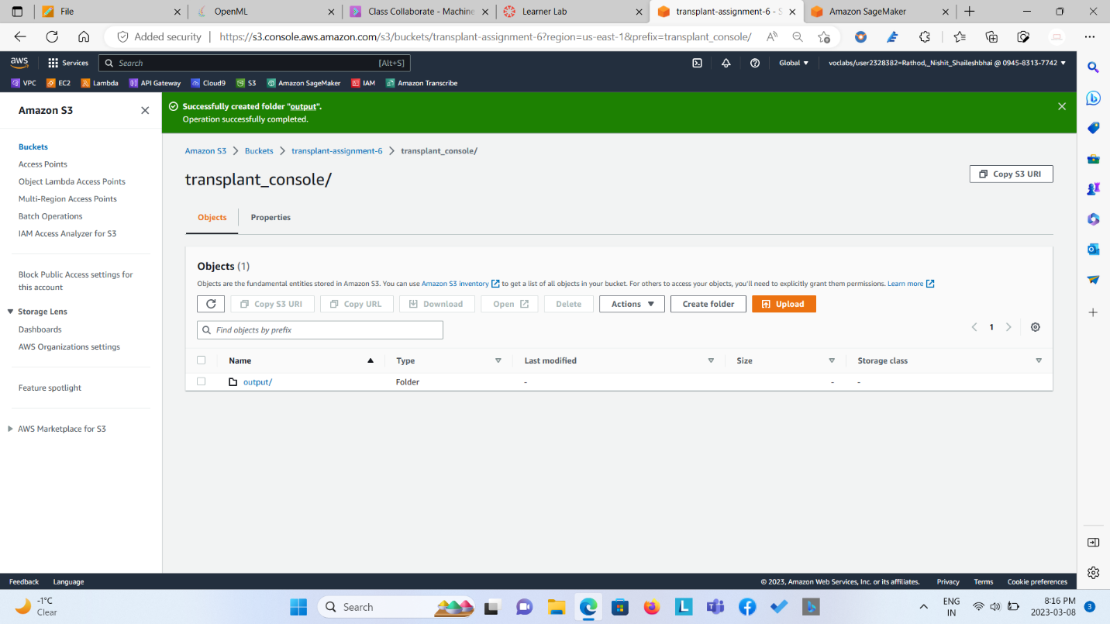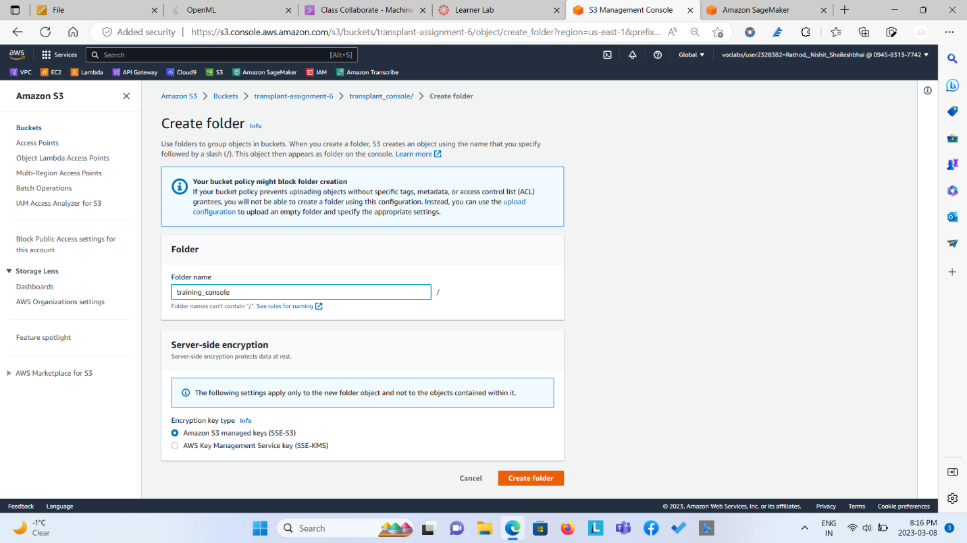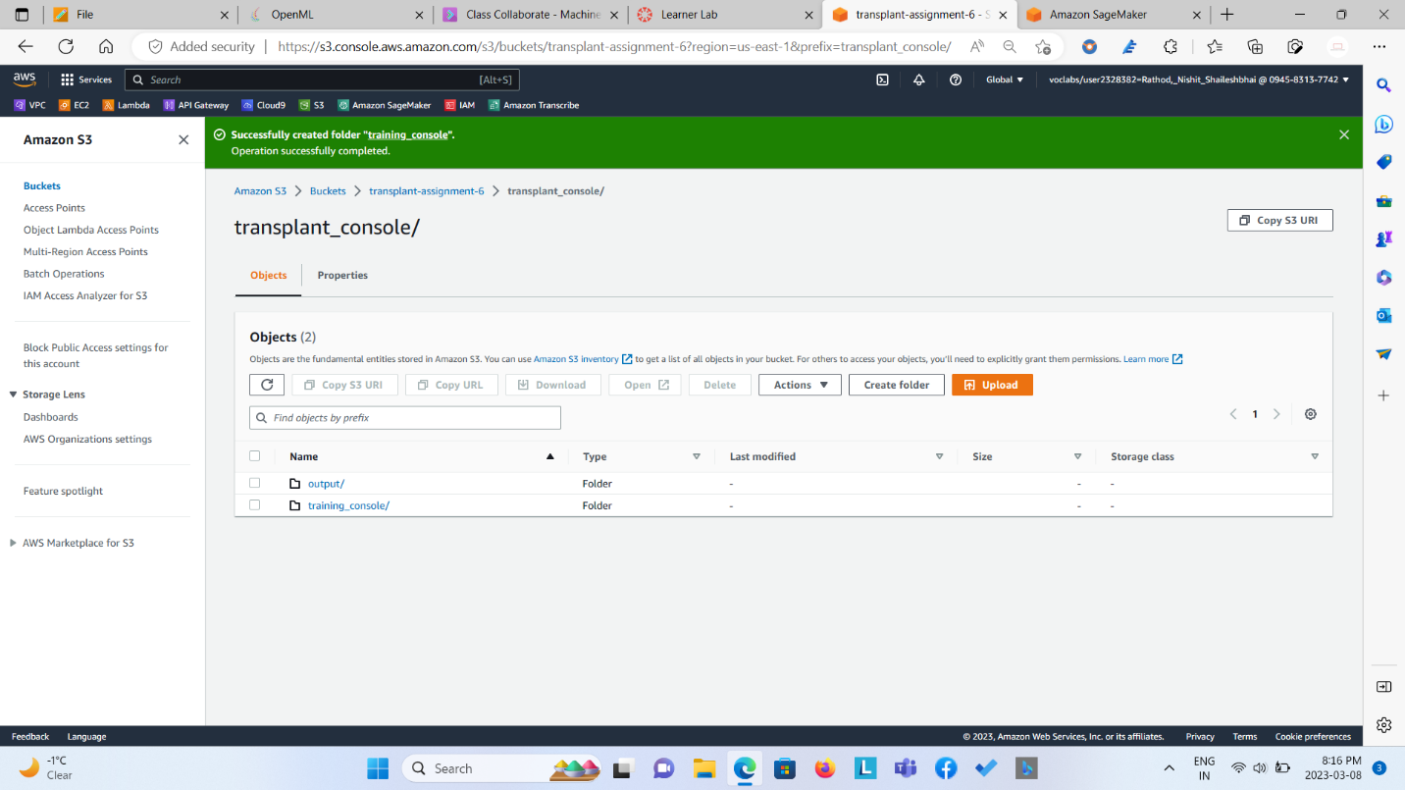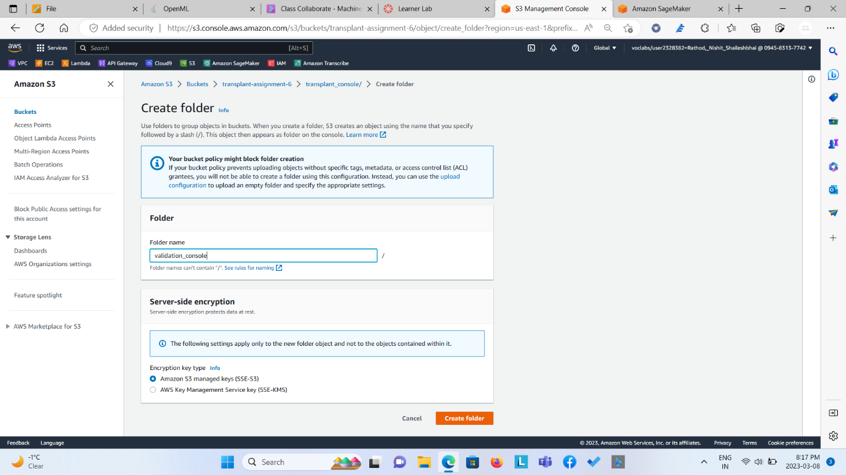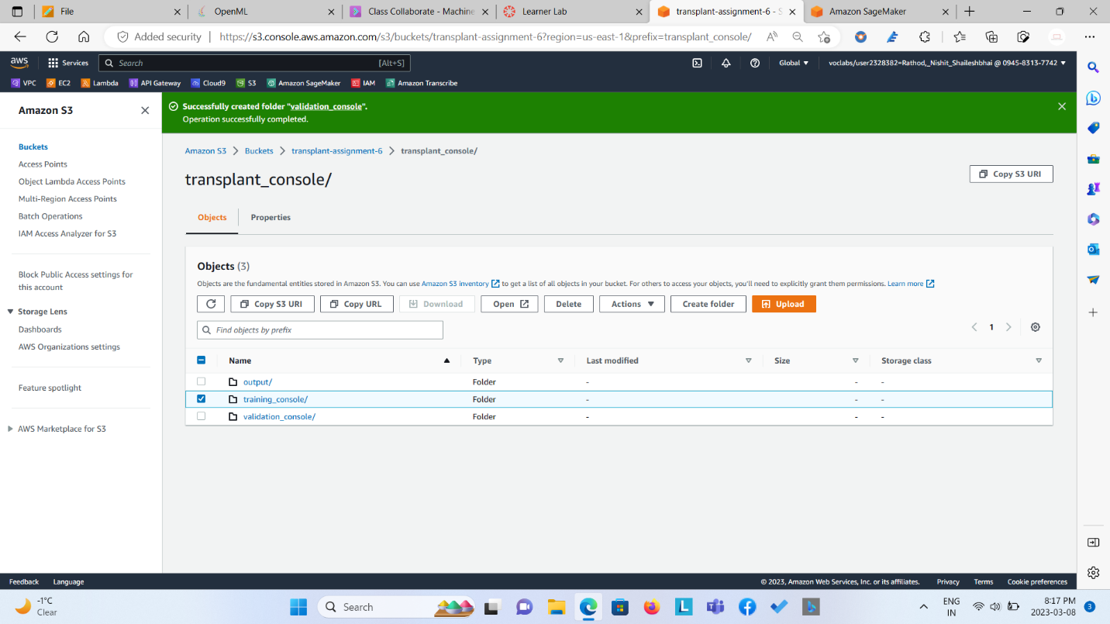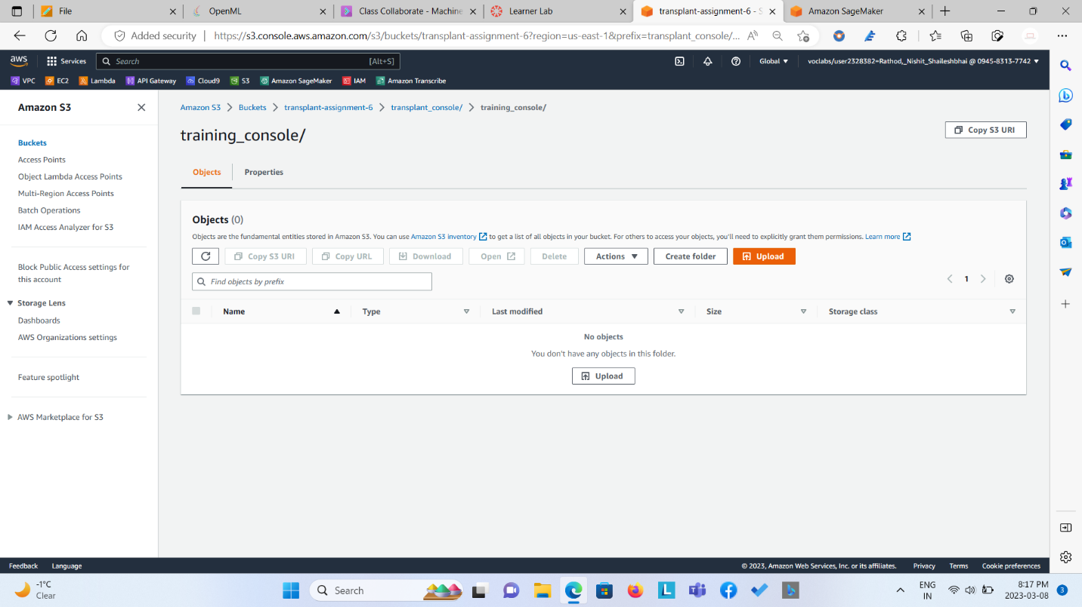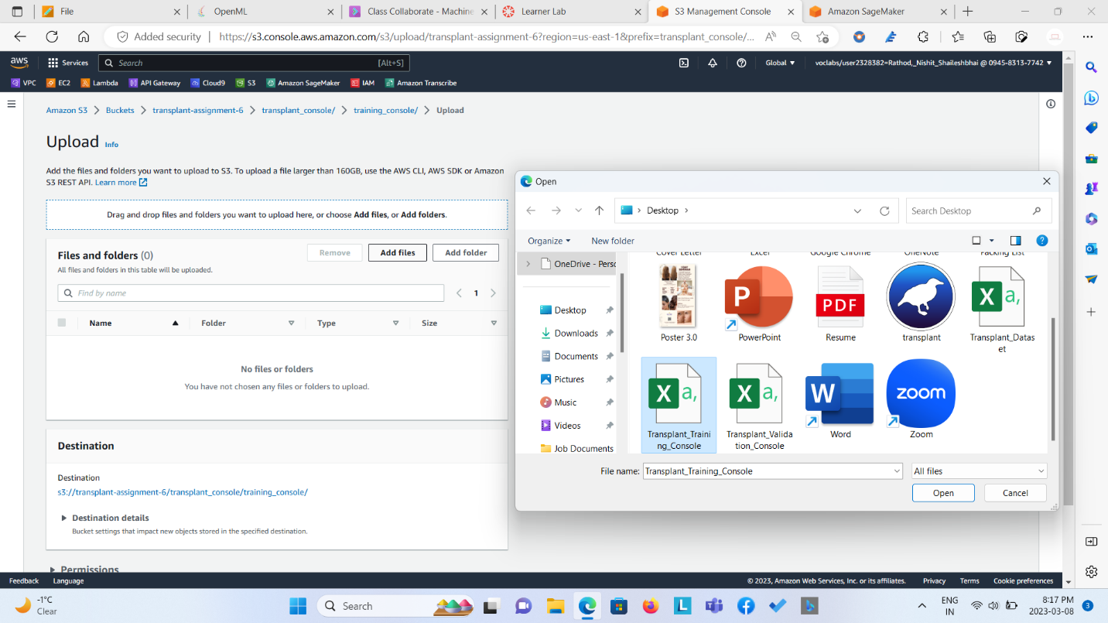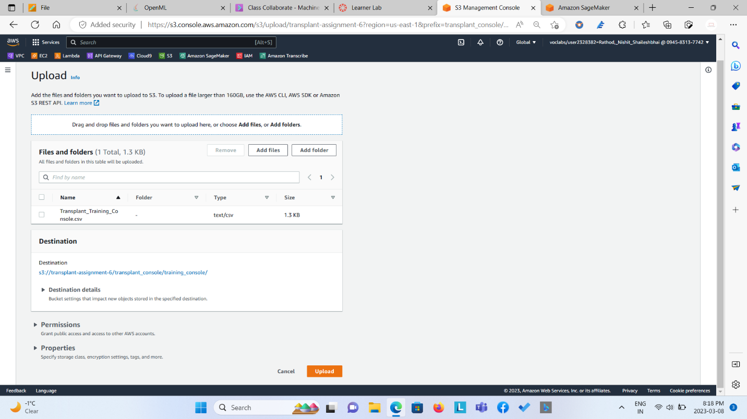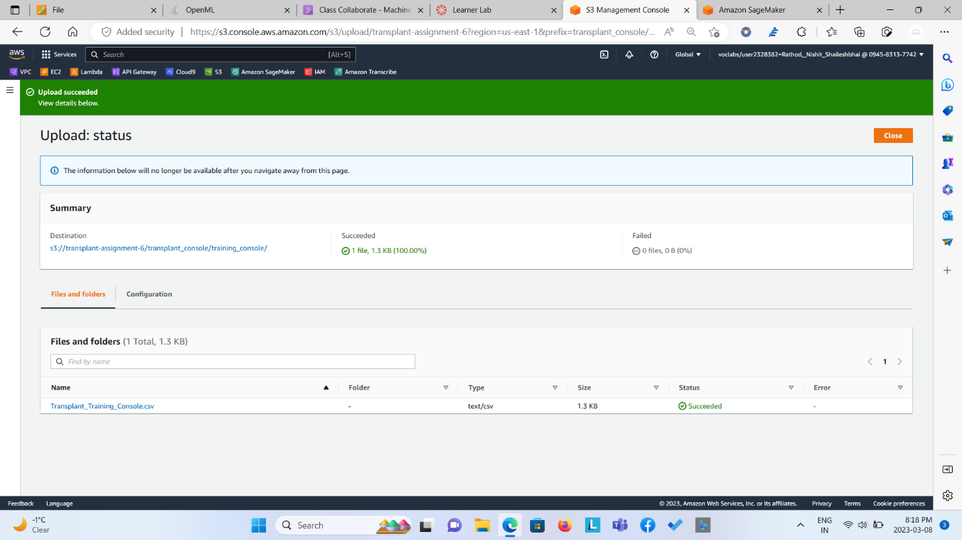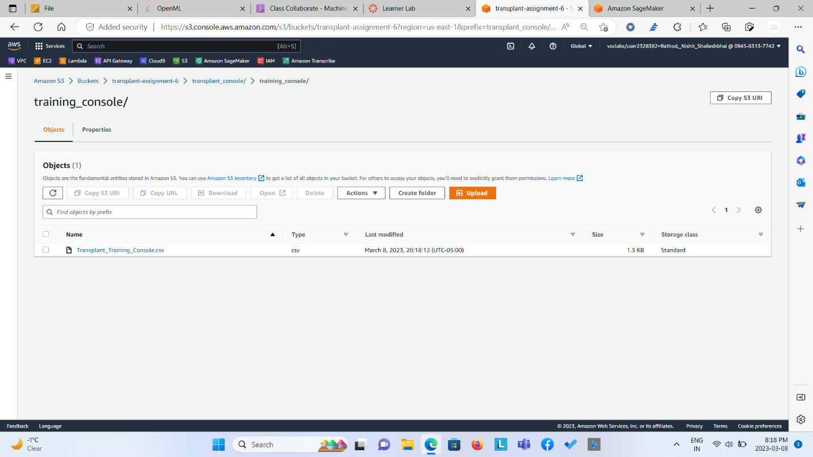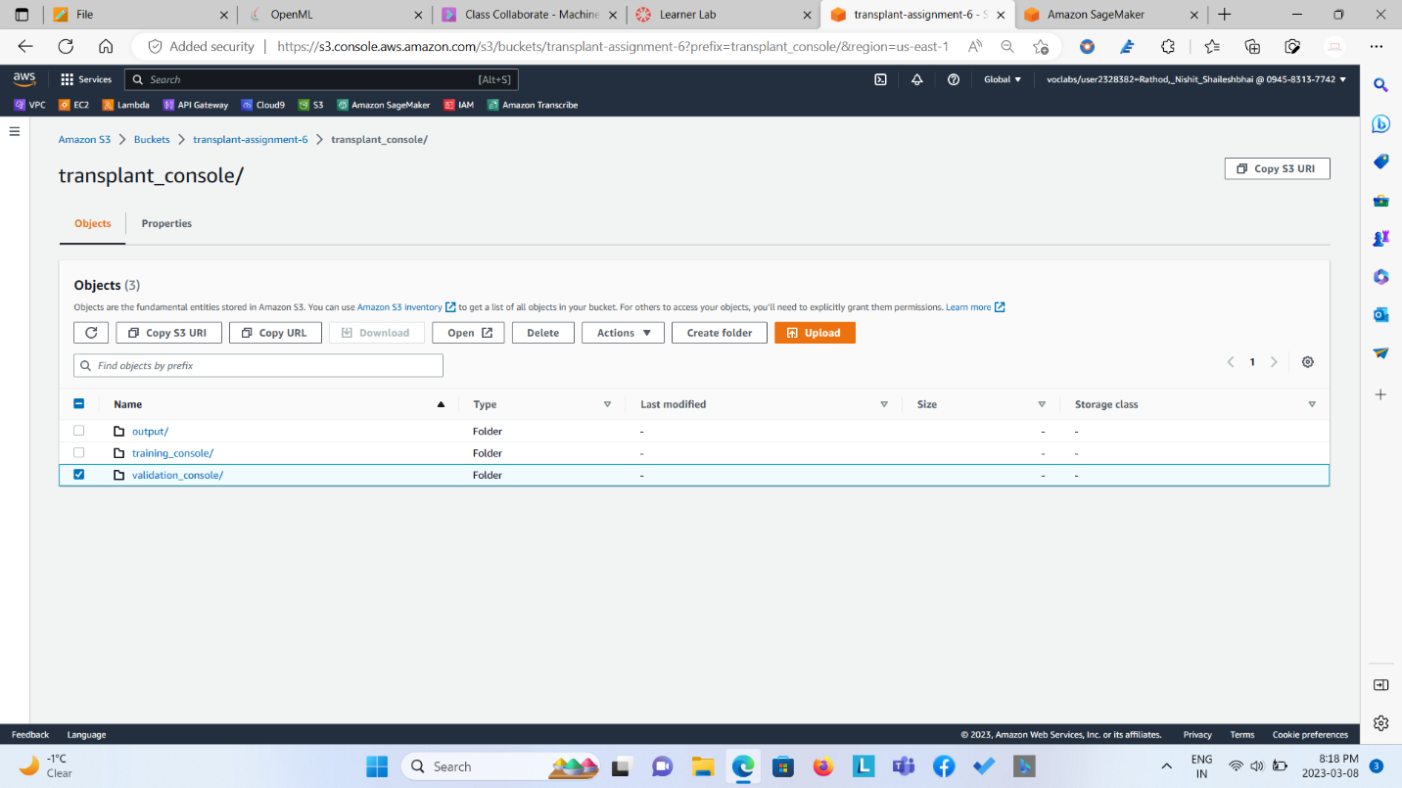

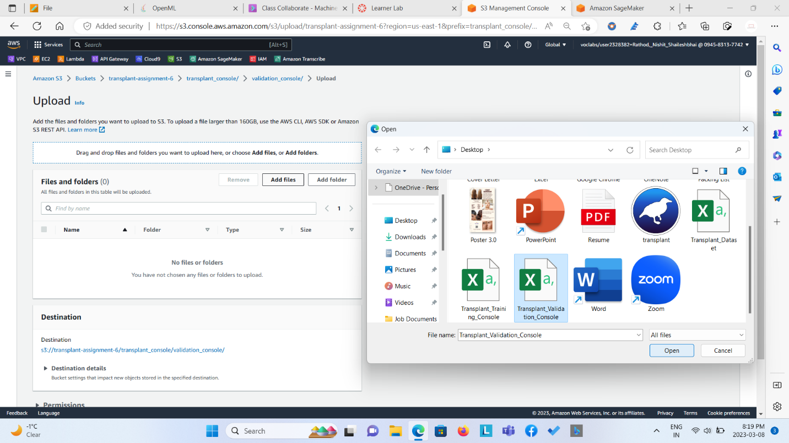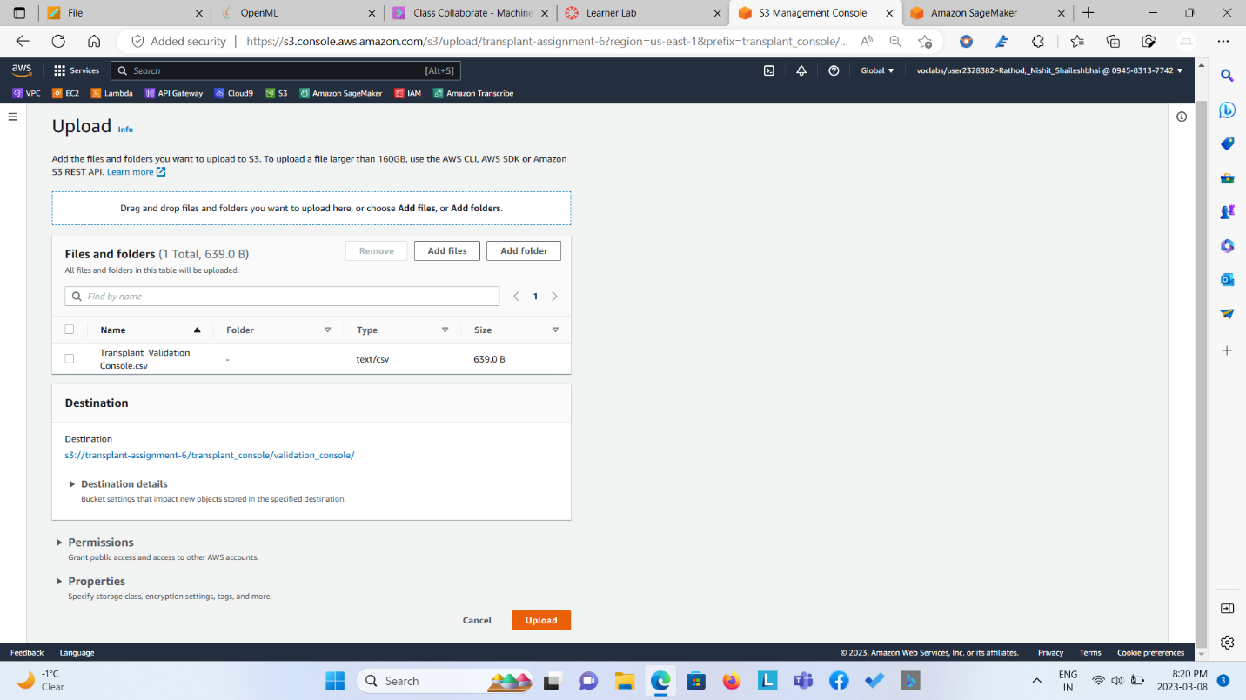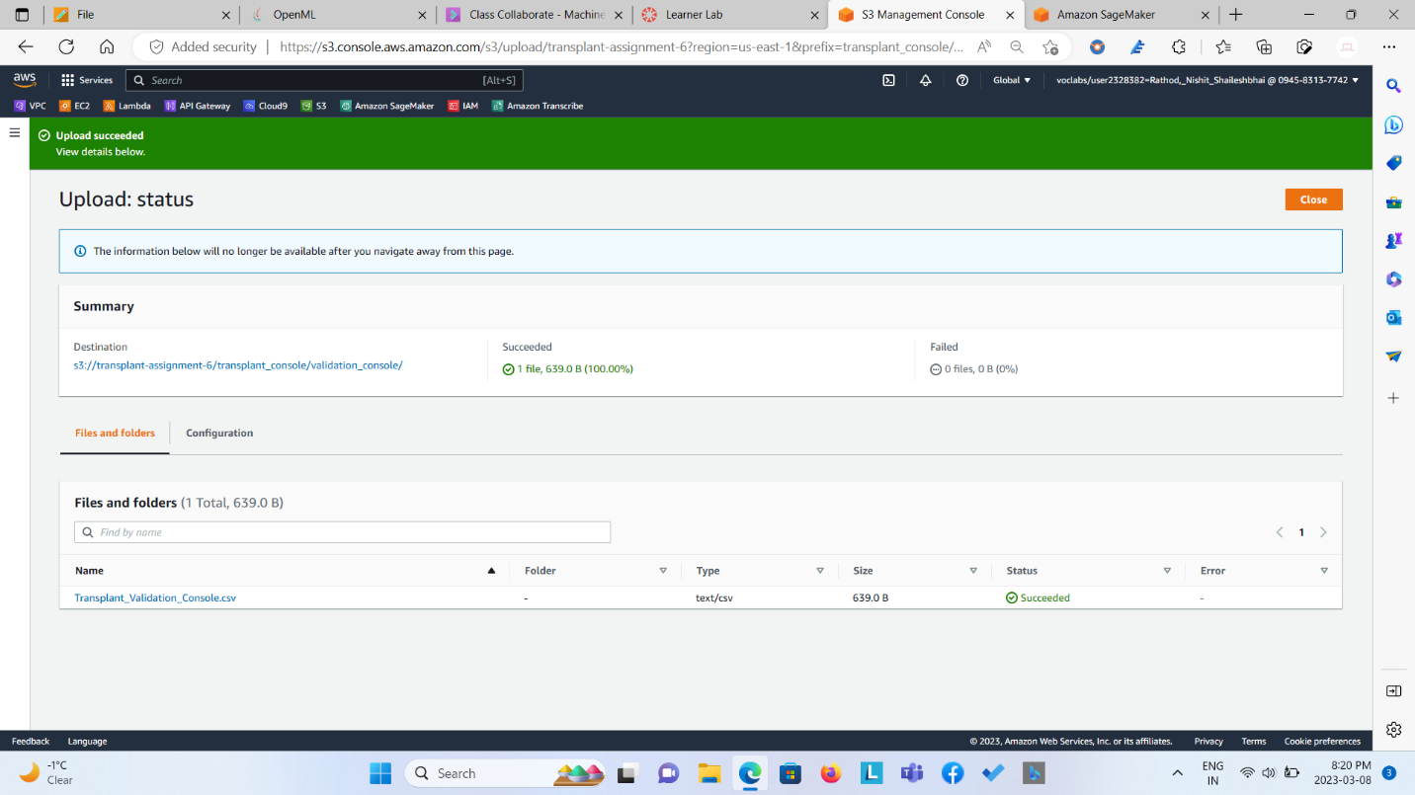

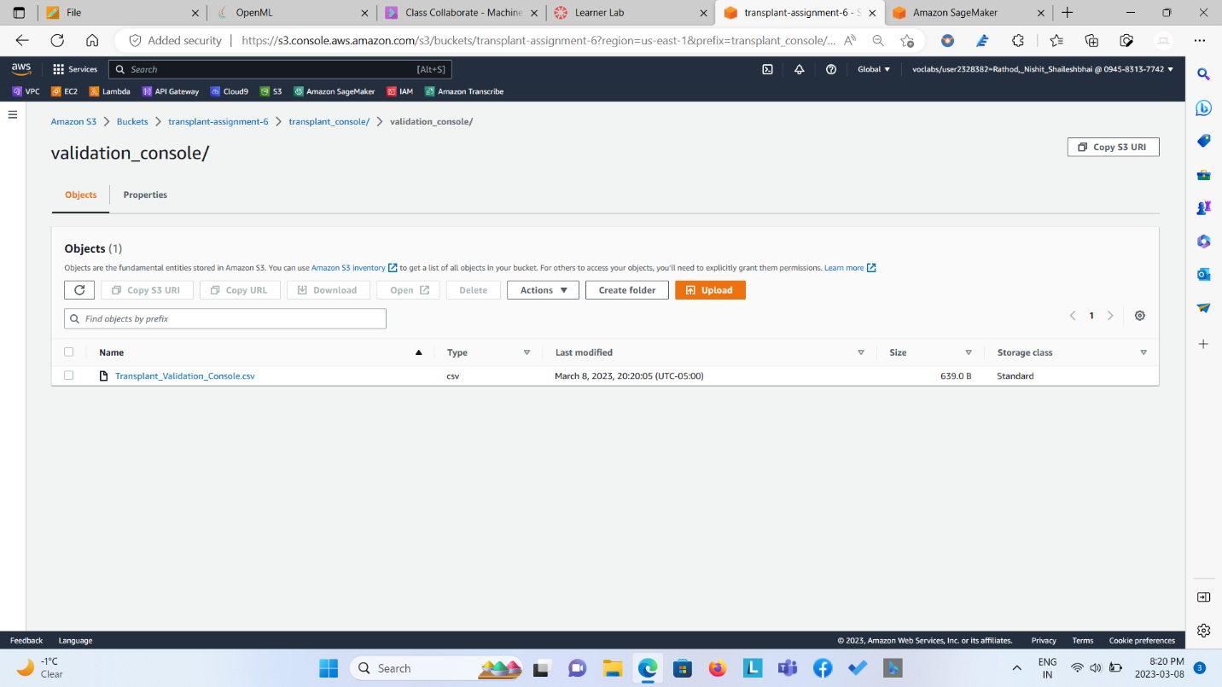

**Step 3: Create a Training Job from Sage Maker’s Training Tab.**

* **Select SageMaker built-in algorithm.**
* **Select XGboost Algorithm.**
* **Select the server that you want to train.**
* **Set the hyperparameter values.**
* **Define two channels for data: one for training data and another for validation data.**
* **Set the training channel with correct S3 bucket location.**
* **Set the validation channel with correct S3 bucket location.**
* **Set the output folder by pasteing S3 output folder path.**
* **Start the training job.**
* **Review the training job.**
* **See the result of training job in the output folder as model.tar.gz file.**

